# **Requirements**

## **Introduction**

* As technology advances, everything is getting automated, HealthCare is not exception.
* Life is everything, time is crucial, in emergency situations time plays a very important role, if we delay it can cost a person life. Hospitals should have good Management system.
* A good hospital management system would facilitate the expansion of the hospital network by easily managing resources, avoiding waste, creating an efficient workforce, and better data management.
* Such a system could provide hassle-free patient care and make everyone's job much easier.
* Hospital management software is a web-based system that works to manage different aspects of a medical facility.
* Its objective is to dematerialize the different processes of the medical center.
* It integrates all important data about doctors, patients, staff, administrative details, etc. There is a growing demand for healthcare app developers and for all the right reasons.

## **Research**

* In this speedy world of medicine, it is an intimidating task to manage a multi talented hospital.
* A hospital management system is a computer or web based system that makes it easy to manage the work of the hospital or any medical set up.
* In covid-19 and similar situations people are willing to consult doctors from home through a mobile app which is entirely software oriented.
* Sooner days, most of the people consult doctors for their health issues from home with their flexible appointmented timings.
* This software will help in building the entire work as paperless.
* This project combines all the information as regards patients, doctors, staff, hospital administrative details and so on, into one software.

## **Cost and Features**

### ***Cost***

Since the system uses only open source software, it is free of cost..!!

*TBD*

### ***Features***

The various features/options for interconversion of the system are:

1. Maintain digital records
2. Less time consuming
3. Track and avoid mistakes
4. Easy to understand

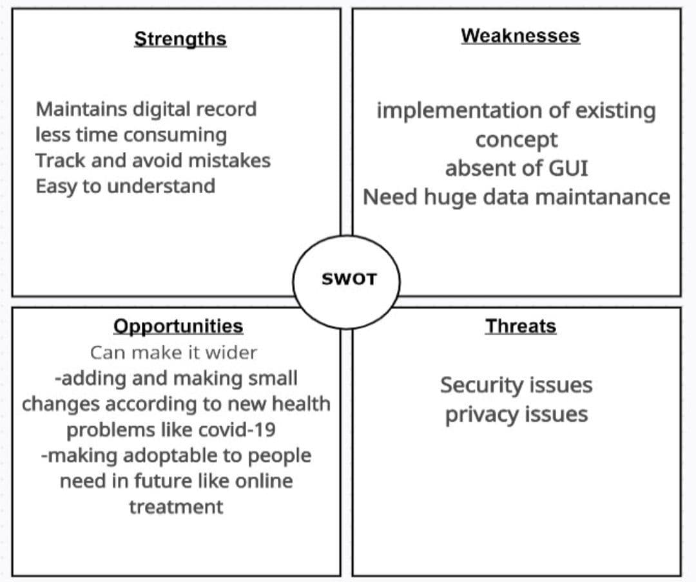

# **4W's and 1'H**

## **Who:**

The Software helpful for patients, providing hassle free patient care and aso helpful for doctors,staff in doing their jobs easier.

## **What:**

A Management software which hold digital records.

## **When:**

Every human in need of hospital in atleast one time their life span.Life is uncertain Hospitals should be available 24*7, so System should also available 24*7;

## **Where:**

Healthcare centres like hospitals,healthcare camps, blood and organ donations etc.

# **Detail requirements**

## **High Level Requirements:**

| id | Description | Status |
| --- | --- | --- |
| HR_01 | Patient | Implemented |
| HR_02 | Hospital | Implemented |
| HR_03 | Staff | Implemented |
| HR_03 | Advanced health equipment | Future |
| HR_04 | New health problems | Future |

## 

## 

## 

## 

## 

## **Low level Requirements:**

| id | Description | Status |
| --- | --- | --- |
| LR_01 | Outpatient | Implemented |
| LR-02 | Inpatient | Implemented |
| LR_03 | Laboratories | Implemented |
| LR_04 | Pharmacy | Implemented |
| LR_05 | Operation Room | Future |
| LR_06 | Doctor | Implemented |
| LR_07 | Nurse | Implemented |
| LR_08 | Technician | Implemented |
| LR_09 | Security | Implemented |
| LR_10 | Back up data | Future |
| LR_10 | Update according to new health issues | Future |